United States of America
Statue of liberty  New York  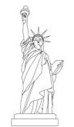 | 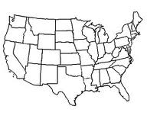  Map of the United States of America | Baseball  Basketball  Football
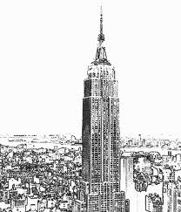  Empire state building  New york  Flag of the United States of America | 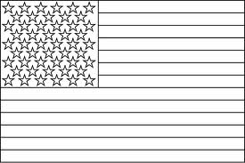 | 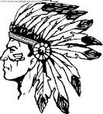  Indians :  native americans
 | 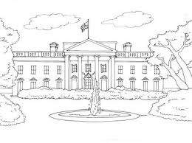
Fast-food | The White House Washington DC | Cinema

