The classroom song  Sit down 1 2  Look at your shoe ;  Stand up 3 4  Look at the door  Be quiet ; listen and look (clap, clap)  Be quiet ; listen and look (clap, clap)  Walk 1 2 3 and 4  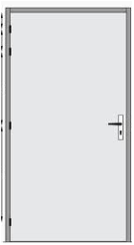  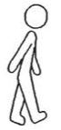  Walk 1 2 3 and 4  Stop, open the door (clap, clap)  Stop, close the door (clap, clap)  Come here ! 5 6 7 and 8  Come here ! 5 6 7 and 8  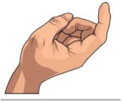  Stop ! Write the date (clap, clap)  Stop ! Write the date (clap, clap)  Back up 9 10  Say it again  10 9 8 (clap, clap)  7 and 6 (clap, clap)  5 4 3  2 and 1  Stop ! | The classroom song  Sit down 1 2  Look at your shoe ;  Stand up 3 4  Look at the door  Be quiet ; listen and look (clap, clap)  Be quiet ; listen and look (clap, clap)  Walk 1 2 3 and 4  Walk 1 2 3 and 4  Stop, open the door (clap, clap)  Stop, close the door (clap, clap)  Come here ! 5 6 7 and 8  Come here ! 5 6 7 and 8  Stop ! Write the date (clap, clap)  Stop ! Write the date (clap, clap)  Back up 9 10  Say it again  10 9 8 (clap, clap)  7 and 6 (clap, clap)  5 4 3  2 and 1  Stop !

