School day chants

Welcome | Good morning  Welcome in  -Good bye Mummy !  -Good bye Daddy !  Good morning teacher  Good morning friends  Boys and girls
Morning gathering | It’s time to tidy  Let’s get ready  It’s time to tidy  We are busy !
Playground | Let’s go outside  In the playground  Let’s go outside  Play and run and hide !
Snack time | If you’re hungry and you know it  Make a row  If you’re hungry and you know it  Make a row  Two by two let’s go and eat  If you’re hungry and you know it  Make a row
Toilets | Let’s go poty  Pee-pee, poo-poo  Let’s go poty  And whipe it all !
Teeth | Brush, brush, brush your teeth  Properly  From gums to teeth  Brush, brush, brush your teeth  Properly = no cavities !
Hands | Wash, wash, wash your hands  Properly  Wash, wash, wash your hands  Properly = no bacteries
Nap | Go to sleep  Little bunnies  Go to sleep  You are sleepy  Take a nap  Little bunnies  Take a nap and make sweet dreams
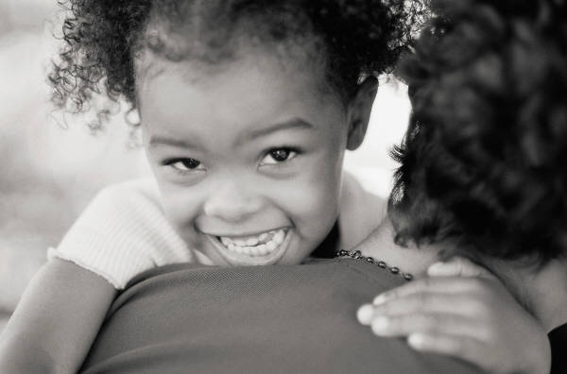  Parent’s time | Children, now it’s time for cleaning  Your parents are soon coming  Just enough time for a story  Do come and sit by me

THE ANTS ARE MARCHING Tune: “When Johnny Comes Marching Home Again”
The ants are marching to the hive, hooray! hooray! The ants are oh so quiet as they come my way. Some come fast, some come slow. All are marching as they go. Oh, I’m oh so glad, the ants could come today. Jean Warren
(Children start marching quietly to the Circletime area.)
SURPRISE APRON Tune: “The More We Get Together”
Something’s in my pocket, my pocket, my pocket. Something’s in my pocket, oh what could it be? Come and join me. Then everyone will see. What’s in my pocket, oh what could it be? Jean Warren
(Teacher wears an apron with large pockets, where she hides a surprise.)

RING, RING, RING YOUR BELL Tune: “Row, Row, Row Your Boat
Ring, ring, ring the bell So everyone can hear. Time to gather round Circle time is here. Jean Warren
(Sit at circle time area. Give a bell to the first child to join you. Have them ring the bell while you sing the song above.)
IF YOU’RE READY FOR A STORY Tune: “If You’re Happy And You Know It”
If you’re ready for a story, come sit down. If you’re ready for a story, come sit down. Let’s all gather near, so everyone can hear. If you’re ready for a story, come sit down. Jean Warren

IF YOU’RE WEARING RED TODAY Tune: “If You’re Happy And You Know It”
If you’re wearing red today – follow me. If you’re wearing yellow today – follow me. If you’re wearing blue today – then come along this way. If you’re wearing green today – follow me. Jean Warren
(Start singing, have children line up behind you as you call out their color. Continue the song with different colors until everyone is walking behind you. Lead everyone to the Circle Time area.
I WIGGLE MY FINGERS
(A Movement Rhyme)
I wiggle my fingers,
I wiggle my toes,
I wiggle my shoulders,
I wiggle my nose.
Now no more wiggles
Are left in me,
So I can sit as still as can be.
Adapted traditional

TWO LITTLE FEET
(A Movement Rhyme)
Two little feet go tap, tap, tap.
Two little hands go clap, clap, clap.
One little body, twirls around.
One quiet body sits back down.
Adapted Traditional

OPEN YOUR HANDS
(A Movement Rhyme)

Open your hand,
Then clap, clap, clap
Now, you lay them in your lap.
Two little eyes looking straight ahead.
Two little ears, hearing what is said.
Adapted Traditional

LET’S ALL HELP
Tune: “Frere Jacques”

Let’s all help.
Let’s all help.
Pick up the toys.
Pick up the toys.

Then when we are done.
We’ll have lots of fun.
Let’s all help
Pick up the toys.
Adapted Traditional

IT’S TIME TO CLEAN-UP Tune: “The Farmer In The Dell” It’s time to clean up now. It’s time to clean up now. Heigh-ho, just watch us go. It’s time to clean up now.
We’ll put our things away.
Ready for another day.
Heigh-ho, just watch us go.
We’ll put our things away.
Jean Warren

IT IS STORY TIME
Tune: “Frere Jacques”

It is story time.
It is story time.
Circle ‘round,
Then sit down.

When our ears are ready.
When our hands are steady,
We will start
The best part.
Jean Warren

WIGGLE WORMS
(A Movement Rhyme)

Once there were some little worms.
And all they did, was squirm and squirm.
They wiggled and wiggled up and down.
They wiggled and wiggled all around. (Let your children around for a while)
They wiggled and wiggled and wiggled until, They were tired and could sit very still. (Have children sit down)
Now they could listen,
Now they could see
All of the things
I have here with me. (Start your story or circle time activity)
Jean Warren

