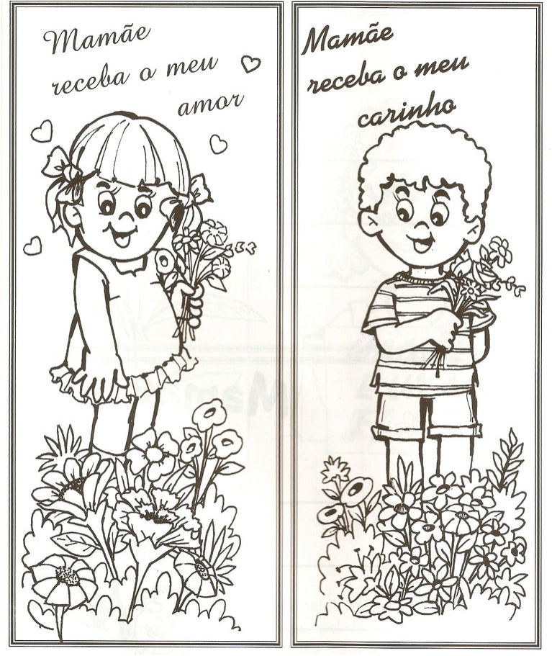
Happy mother’s day !
Happy father’s day !

Happy mother’s day !
Happy father’s day !

