Great Britain

Stonehenge  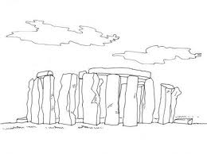 | 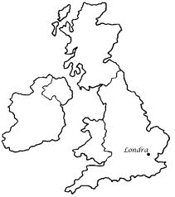  Great Britain map | -Taxi : cab  - a telephone booth
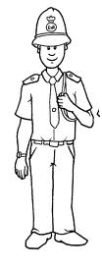  Policeman :  Bobby  A guard |  | Big ben  Bus : double-decker  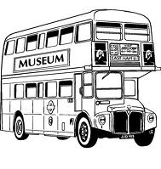
England |  | 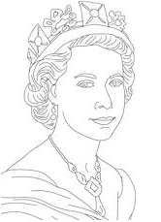
 | « Union Jack » flag | Queen Elizabeth II

