Echéancier « The very hungry caterpillar »
Petite Section M2
 | Comprendre | Parler
 | Ecouter :  Je peux comprendre les personnages de l’histoire : « the very hungry caterpillar ».  -Je reconnais les mots déjà appris (sun, days of the week, little/big…)  -J’apprends de nouveaux mots (caterpillar butterfly, fruits, moon…) | comptines:  Je peux communiquer de façon simple en chantant des comptines en rapport avec l’histoire « The very hungry caterpillar »
 | 8d-8e-8i-6b-6i-6f-6j-6m- | 5a-6j
Baouva Gaël | ☺ | ☺
Bonnaire Manon | ☺ | ☺
Bouteiller Timothé | 😐 | 😐
Dos Santos- Calmels Matthias | ☺ | ☺
Faufingue Nina | ☺ | ☺
Filimokailagi Atakula | ☺ | ☺
Fitialeata Kilisina | ☺ | ☺
Gilbert Moïra | 😐 | 😐
Holoia Tracy | ☺ | ☺
Kaikilekofe Vaikiria | ☺ | ☺
Keletaona Lenaïc | ☺ | 😐
Keletaona Monaliza | ☺ | ☺
Raysse Morgan | ☺ | ☺
Richard Manon | ☺ | ☺
Sanvoisin Althéa | ☺ | ☺
Talalua Abigail | ☺ | ☺
Talau Owen | 😐 | 😐
Taukafauli Paulo | ☺ | ☺
Vanin Rafaël | ☺ | ☺
Vea Kassidy | ☺ | ☺
Wamejo Christophe | ☺ | ☺

Comptines :

Goog morning !

I clap and say
good morning ! Goog morning ! Good morning !
How are you today ?
Good evening !

I clap and say
good evening ! Good evening ! Good evening !
How are you today ?

Fuzzy Wuzzy caterpillar
Fuzzy Wuzzy caterpillar
Crawling on the ground.

Fuzzy Wuzzy caterpillar
Never makes a sound.

Soon you will be sleeping
Softly lulaby

Then when you will wake
and you will be a butterfly.
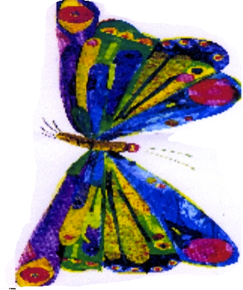
Fly, fly, fly the butterfly !

Fly, fly, fly the butterfly !
In the meadow, it’s flying high.
In the garden, it’s flying low.
Fly, fly, fly the butterfly !

