………………. the …………….th of …………. 2012

Name : ____________________________________

→Cut and glue the pictures.

- How are you ?
1 | 2 | 3 | 4 | 5 | 6
I’m happy | I’m sick | I’m sleepy | I’m sad | I’m fine | I’m angry

- The body:
1 | 2 | 3 | 4 | 5 | 6 | 7 | 8
nose | shoulders | toes | eyes | knees | ears | head | mouth


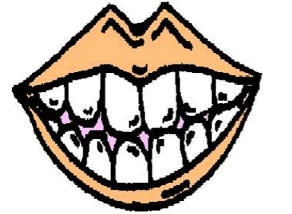 | 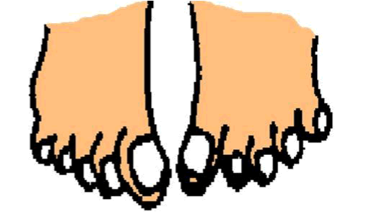 | 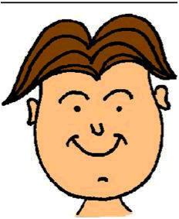 | 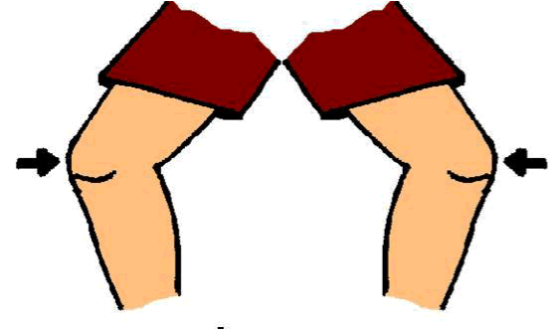 | 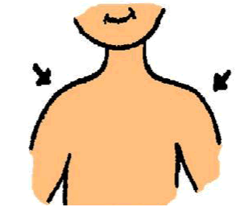 | 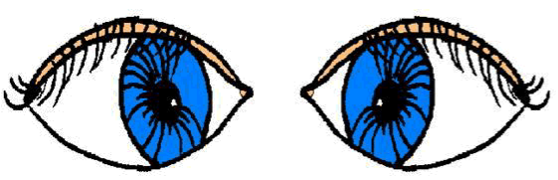 | 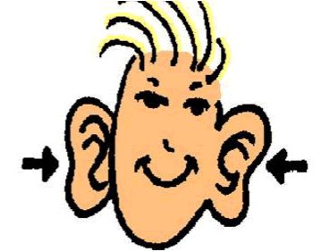 | 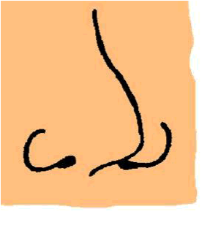

 |  |  | 
………………. the …………….th of …………. 2012

Name : ____________________________________

→Cut and glue the pictures.

- How are you ?
1 | 2 | 3 | 4 | 5 | 6
I’m happy | I’m sick | I’m sleepy | I’m sad | I’m fine | I’m angry

- The body:
1 | 2 | 3 | 4 | 5 | 6 | 7 | 8
nose | shoulders | toes | eyes | knees | ears | head | mouth



