English speaking countries
1  ……………………………  2  ……………………………    3  …………………………. |  | 4  …………………………………..  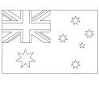  5…………………………............    6  …………………………………

Canada | Australia | Ireland | United kingdom  (U.K) | New zealand | United states of america (U.S.A)

