Red |  | A red bed.
Pink | 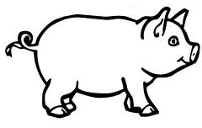 | A pink pig.
Orange | 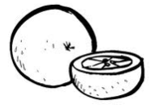 | An orange orange.
Yellow | 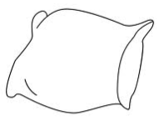 | A yellow pillow.
Green |  | A green bean.
Blue |  | A blue shoe.
Purple |  | A purple bubble.
Brown | 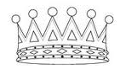 | A brown crown.
Black | 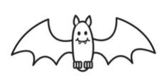 | A black bat.
Grey | 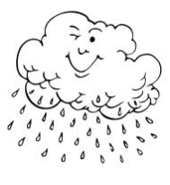 | A grey day.
White | 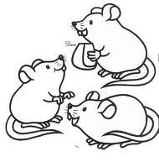 | White mice.
Red |  | A red bed.
Pink |  | A pink pig.
Orange |  | An orange orange.
Yellow |  | A yellow pillow.
Green |  | A green bean.
Blue |  | A blue shoe.
Purple |  | A purple bubble.
Brown |  | A brown crown.
Black |  | A black bat.
Grey |  | A grey day.
White |  | White mice.

