Sit down, sit down
It’s the rain, it’s the rain, it’s the rain
Sit down, sit down
It’s the rain, rain, rain, rain

Jump up, jump up
It’s the sun, it’s the sun, it’s the sun
Jump up, jump up
It’s the sun, sun, sun ,sun

Hide, hide
It’s a spider, it’s a spider
Hide, hide
It’s a spider

Sit down, Jump up, hide, hide, hide
Hide, hide, hide, hide, hide, hide
Sit down, Jump up, hide, hide, hide
It’s a spider

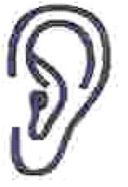
Listen, listen
One, two, three, four, five
Listen, listen
One, two, three, four, five
1, 2, 3, 4, 5
